**User Manual**

Firstly, the user should enter the path of csv file. Then when user run the file, menu will start.

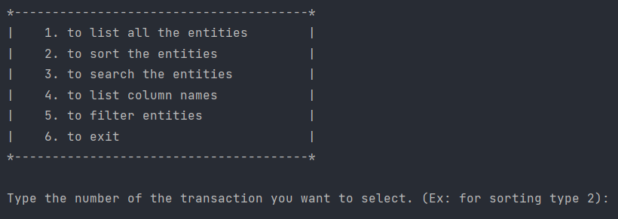

As you can see, there are 6 transactions and the user should enter the number of the transaction. Ex; for sorting user should type 2.

**1- Listing:**

**Listing is the first part of the program. When user type 1 in main menu, then listing options will be displayed on the console and user should type 1,2 or 3 based on their choices.**

**1. To list all the fields**

**2. To list only the selected fields**

**3. To list entities based on the range of rows.**

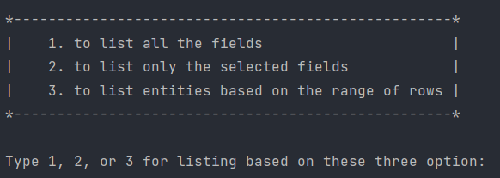

**1) When user input 1 then this output will be displayed:**

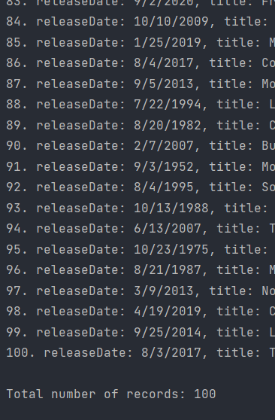

**2) When user input 2 then user will be asked to type a field name. For example, let’s say title. The output will be:**

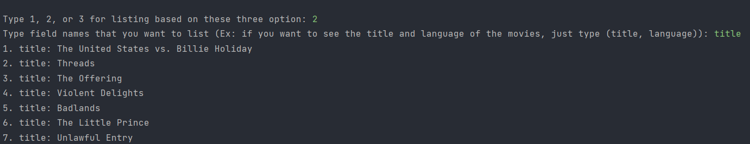

**Only the titles of the films will be displayed on the console.**

**3) When user input 3, then user will be asked to type the start and end of range and the films between these numbers will be displayed (first number is included, but second number is not):**

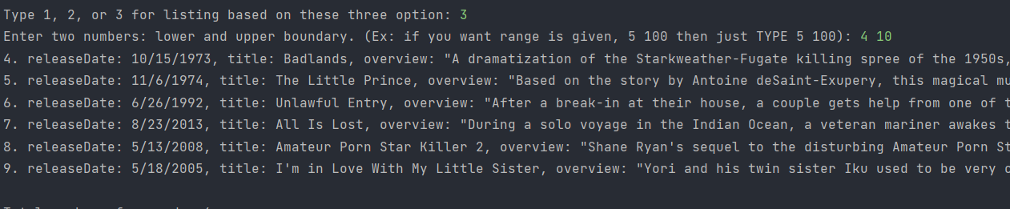

**2- Sorting:**

**When user input 2 on the main menu, In sorting the menu will be like this.**

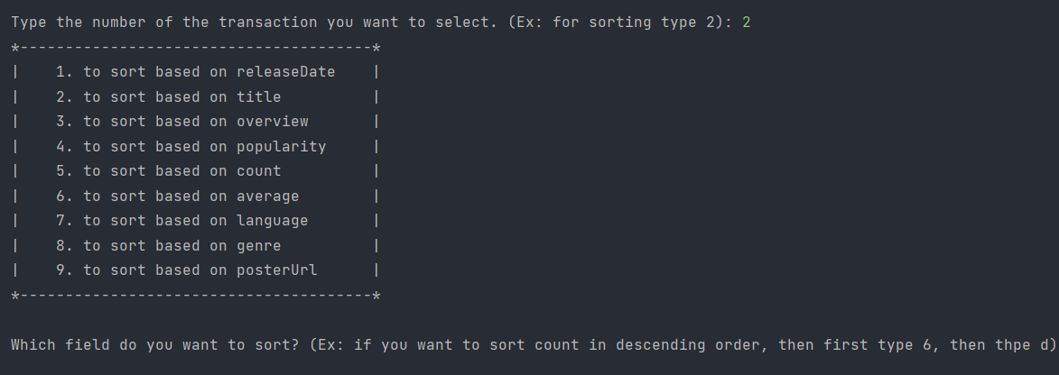

**User will be required to input a field and then user will be asked to type a (ascending) or d (descending). Then we will give the choice to the user to print the entities based on listing options and the printed entities will be based on sort.**

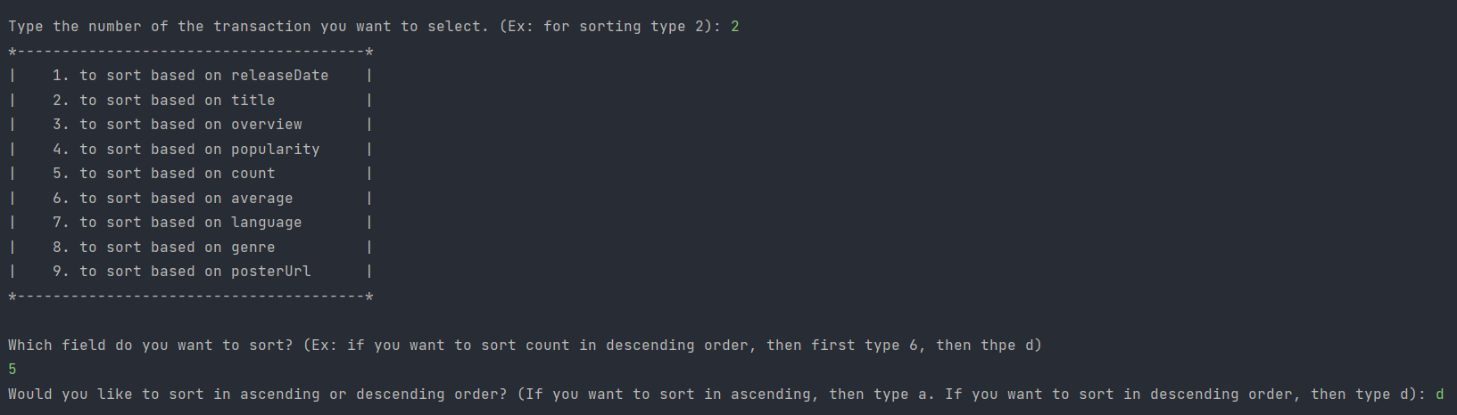

**Here, user choose 5 (count) to be sorted and then he chooses descending order.**

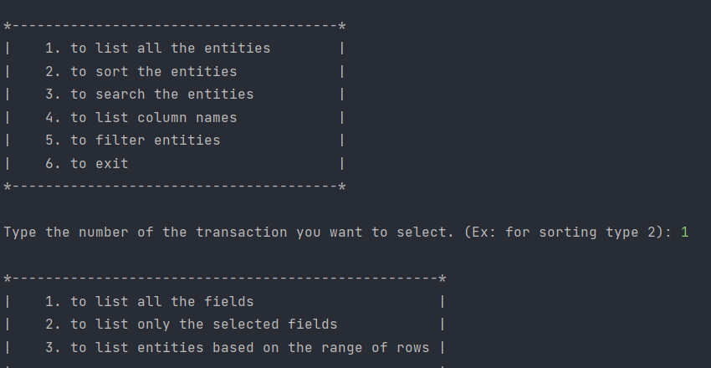

**And then the user will see the main menu and choose 1 (listing) and in order to check whether sorting work or not, user want to list entities based on count (We sorted count in this example).**

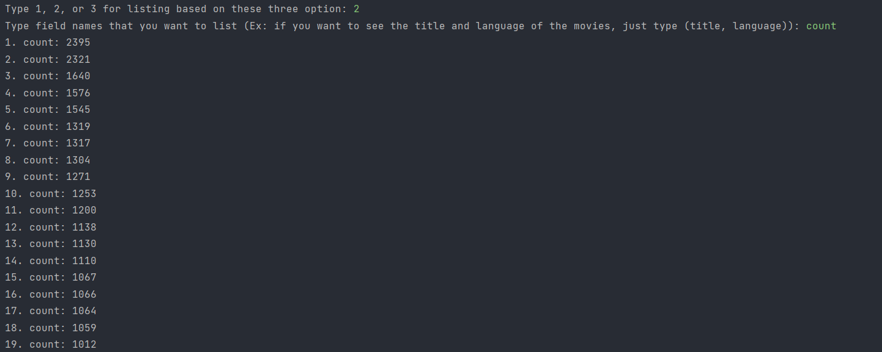

**As you can see, the count is in the decreasing order.**

**3 – Searching – İn searching part, the user should choose 3 in main menu and then user will be required to type a field name. And then is it is a String field then user should type a string and the search algorithm will work based on contains function. It means that if user input th, then code will consider the as a correct match.**

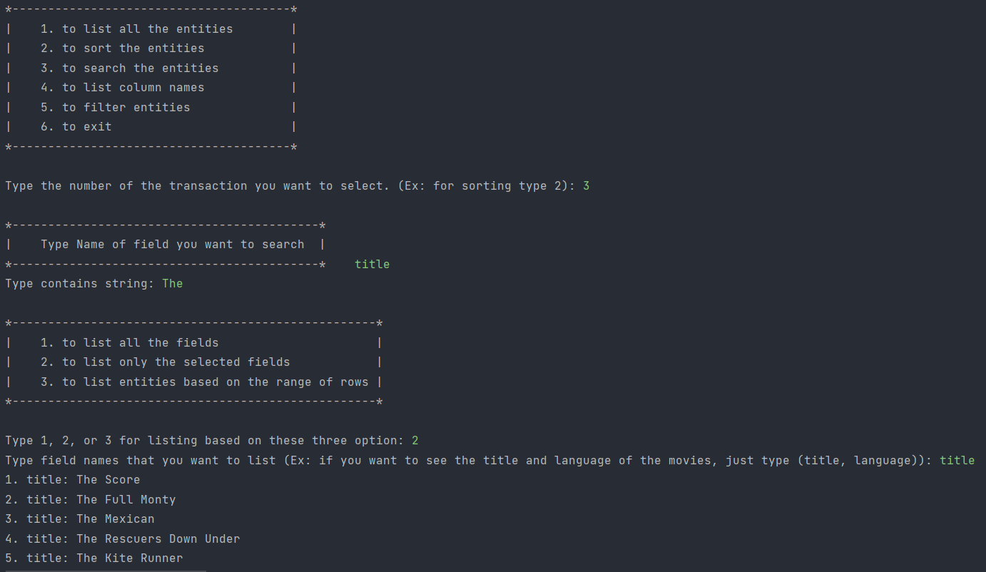

As you can see user enters title and the “The” and then when user list all the movies based on title, user will see only the films which contains “The”.

In non- string fields, the search algorithm works based on exact match. For example, if user chooses count and then type 152, the program will check all the films and try to display all the films that got 152 counts.

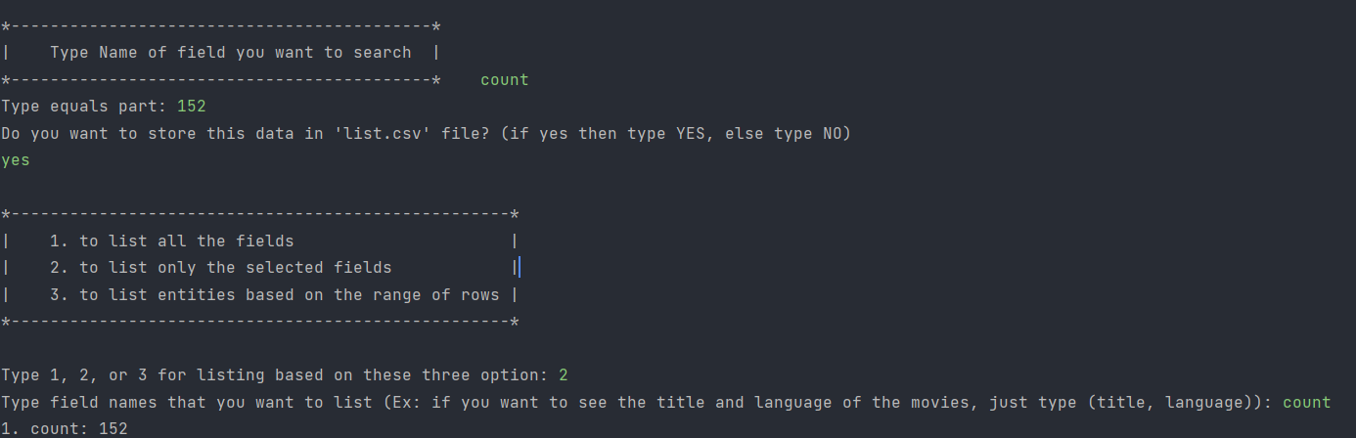

Also, as you can see, we give user extra option to save this output in list.csv file.

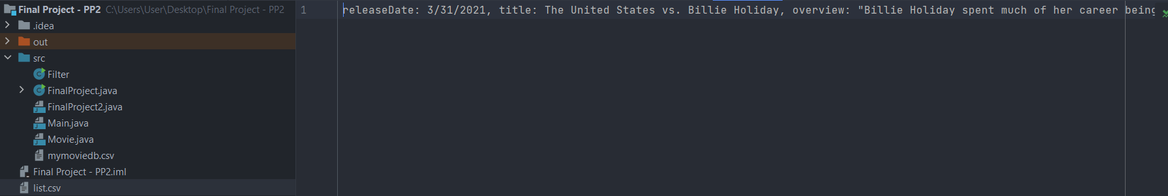

As you can see, there is list.csv file and there is a film which got 152 count.

In genre field, user will see all the genres and then type the name of genre in order to search

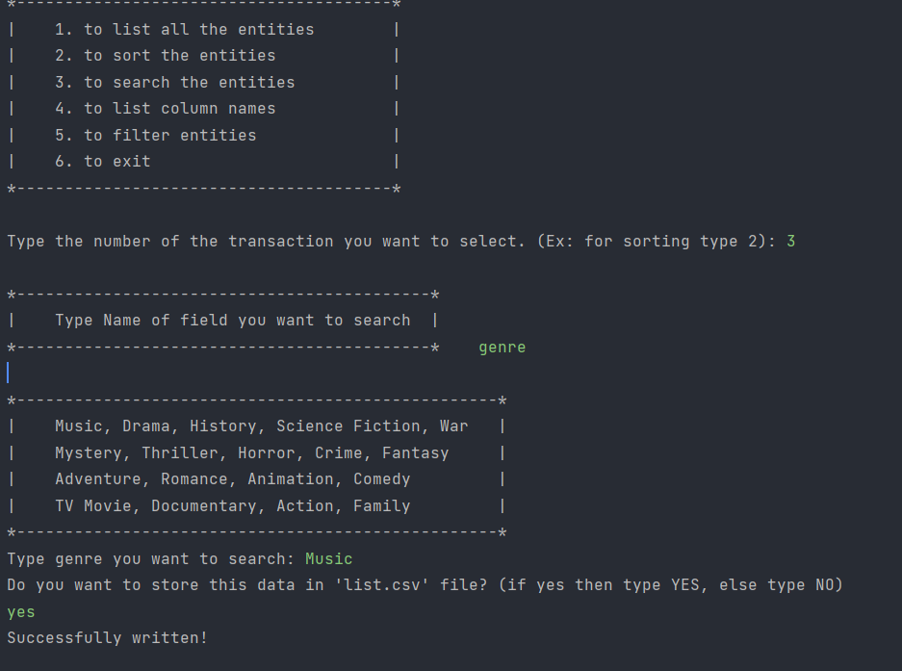

User input genre and then Music. And then he will be asked to store all films that got Music genre and stores it in list.csv file.

4 – List Columns:

Basically, when user input 4 in main menu, user will see all the columns of csv file.

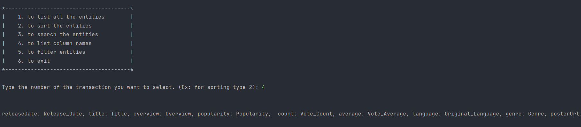

5 – Filtering – In filtering the user will be asked to enter that how many fields he/she would like to filter. For example, let’s say 1. Then user will be required to enter field name and based on this field name, user will see the filtering options. 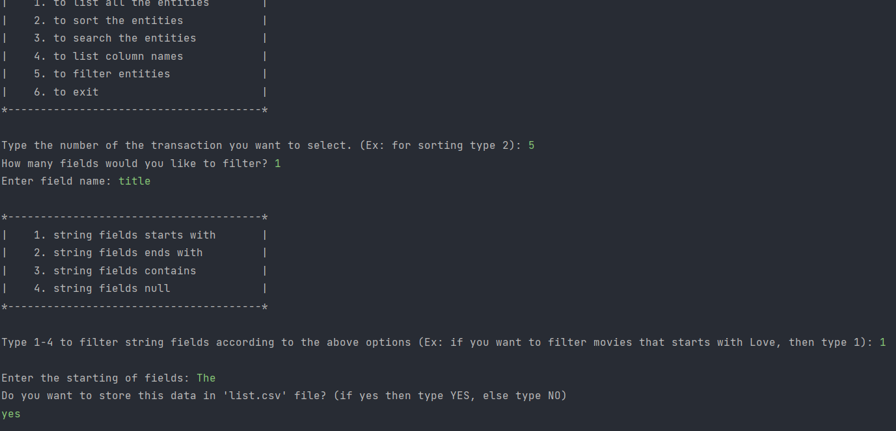

Here user input 5 in main menu and then choose that he/she wants to filter only 1 field. And then enters title (String). He Will see 4 options and based on the number of options, user will choose on of them. Here user chooses 1 (string fields starts with), and type The. It means that user wants to filter all the films which starts with The. And then user will be asked whether he/she wants to save all the filtered films in csv file or not.

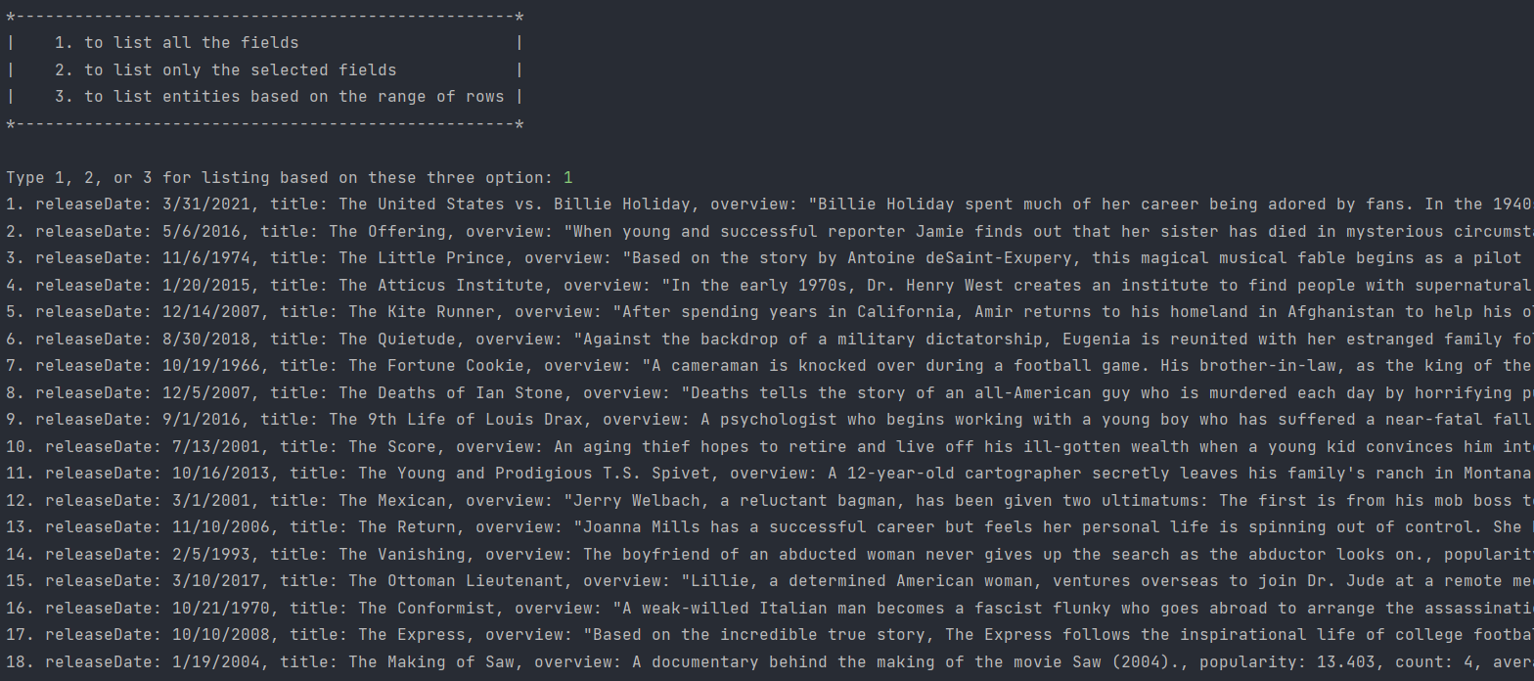

Here user choose that he/she wants to see all the filtered fields and then see all the films which starts with “The”.

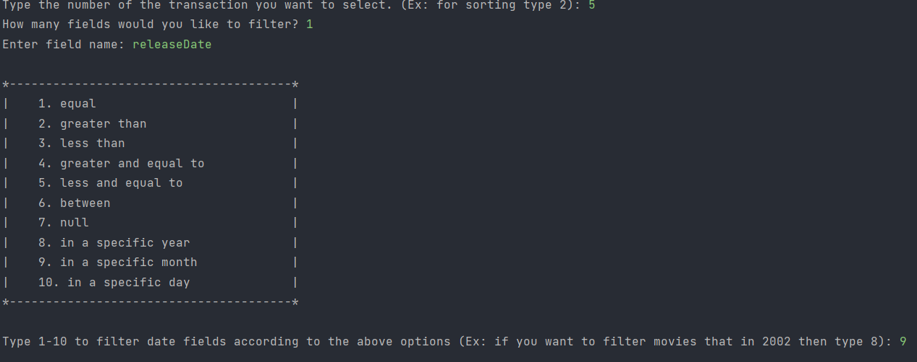

Here user choose to filter releaseDate and the he will be asked to choose one of the 10 options. In this example, user choose 9 (In a specific month). And then user should type the number of month (March – 3, for example).



Here user chooses 3 and then program will find all the films which were released in March, and here used will be asked whether he/she wants to save filtered movies in csv file or not.

6 – Exit – This part of the program will end the program. Normally, the program can handle multiple requests. No need to run the program again.